**eWALL overview**

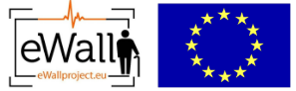

**This document presents an overview of eWALL that can be used by the eWALL Open Source Community. The document belongs to eWALL consortium and any use of the document requires the reference to eWALL Open Source (http://gitghub.com/ewallprojecteu)**

# Table of contents

Table of contents 2

1 eWALL Concept and Architecture 3

1.1 eWALL concept 3

1.2 eWALL Architecture 4

1.2.1 eWALL Home Environment 5

1.2.2 Cloud Gateway 7

1.2.3 Remote Proxy 11

1.3 Service Architecture 12

1.4 Applications 14

1.4.1 Falls Prevention Program 14

1.4.2 Rewards System 15

1.4.3 Caregiver Application 16

1.4.4 Cognitive Games 17

1.5 Challenges and Solutions for the eWALL User interface 18

1.6 Data protection by design 21

2 Developing services and applications in eWALL 25

2.1 eWALL open-source 25

2.2 Development of Service bricks 25

Acknowledgement 30

References 30

# eWALL Concept and Architecture

## eWALL concept

The concept of eWALL resides at the intersection of the concepts of Ambient Assisted Living (AAL), Enhanced Living Environments (ELEs) and Ambient Intelligence (AmI). eWALL, similarly as AAL, is utilizing ICT technologies to facilitate independent living of elderly people by building ELEs to offer them support in everyday activities. eWALL puts a special emphasis on user interaction and, similarly as AmI, brings intelligence to the end user environments equipped with sensors. eWALL objective is to support independent living, compensating for prevailing age-related physical and cognitive impairments, leading to a significant prolongation of their functional capacity, a delay in institutionalization, increased autonomy and improved quality of life.

eWALL is envisaged as holistic infrastructure model and an affordable, prefabricated, easy to install system that can be mounted on the existing wall and that will fade into the background. The eWALL system focuses on the needs of the older adults with Chronic Obstructive Pulmonary Disease (COPD), older adults with Mild Cognitive Impairments (MCI) and older adults with age-related impairments. Elderly as they get older typically have to deal with the decline of physical and cognitive abilities. COPD is currently estimated as 4th cause of death worldvide. Patients suffering from COPD are often afraid of performing physical activity as it can lead to exacerbations (shortage of breath) which in turn may lead to hospitalization and rehabilitation. From heathcare point of view this means utilization and cost increase. Cognitive reinforcement via training and other activities that increase cognitive stimulation such as playing special games reduces the risk of deterioration of cognitive functions. Enabling support and self-management of diseases such as COPD, but also MCI and other, while staying home in familiar surroundings is beneneficial for all related parties. It reduces healthcare costs, it enables elderly to live independently longer in their home while also offering peace of mind to their loved ones.

The multidisciplinary approach was used to determine the needs of that specific target groups and to create a dynamic “caring home” environment capable of “sensing” and “learning”. In order to preserve and enhance health, functional capabilities, self-confidence, safety and mobility the eWALL system includes the scalable, modular cloud-based platform capable of integrating various off-the-shelf and custom devices. eWALL Cloud platform can support any number of Sensing Environments based in primary user home and responsible for explicit and implicit interaction with the primary user, as shown on Figure 1.



Figure 1: eWALL Cloud and Sensing Environment(s) relation

## eWALL Architecture

Figure 1 depicts the high-level eWALL system architecture. It is evident that the eWALL system comprises two distinctive logical entities, i.e. the eWALL Home and the eWALL Cloud Environments.

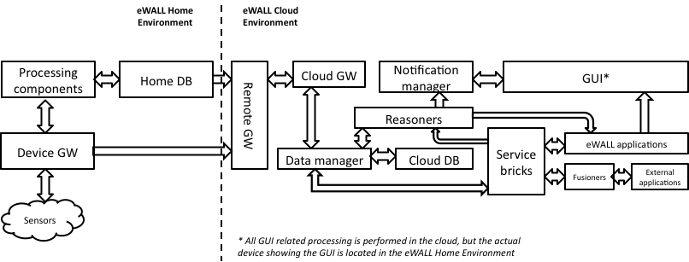

**Figure 2: eWALL high-level system architecture**

The eWALL Home Environment resides in patients’ homes and hosts the sensing capabilities of the entire system. The eWALL sensing (provided by the ‘Sensors’ in Figure 2) can be further classified as:

* Environmental parameters sensing (e.g. temperature, luminosity etc.)
* Vitals parameters sensing (e.g. SPO2, pulse, heart rate etc.)
* A/V sensing (e.g. presence, mood detection etc.)

Market available off-the-shelf devices provide all sensing capabilities within. The Device Gateway (GW) is responsible for seamless integration of the different devices and transparent integration with the eWALL Cloud Environment. The ‘Processing components’ is responsible for quick interpretation of sensing data for critical purposes such as presence detection, fall detection etc. The ‘Home DB’ keeps track of patients’ data temporarily before it is transferred in the ‘Cloud DB’ for permanent storage.

The eWALL Cloud Environment is a centralized system responsible for hosting and analyzing all patients’ data coming from patients’ homes. The ‘Remote GW’ accepts the data from the patients’ homes whereas the ‘Cloud GW’ actually interconnects the Home and the Cloud Environments by receiving processed and indexed measured sensor data. The ‘Data Manager’ offers multiple functionality features like data processing, validation and exchange. The ‘Notification manager’ is a processing entity capable of managing (i.e. storing, forwarding or deleting) all eWALL notifications. It is a single central block where all notifications are being managed, so the user is not overloaded by all information coming randomly from independent notification sources. Its main role is to manage the notifications (alarms) and messages that originate from a specific set of processing blocks, e.g. ‘Service bricks’ and ‘Reasoners’. The ‘Service bricks’ represents a set of eWALL intelligent context aware software components, which together with applications act as a bridge between the end users and the eWALL back-end services. The ‘Reasoners’ provide the intelligence within the eWALL system supporting intelligent decisions and actions based on the available data. The ‘eWALL applications’ and the ‘External applications’ represent the applications that the patients can use from the eWALL system and they are either custom designed and developed (elaborated in the following subsections of this paper) or adopted (through ‘Fusioners’) from general and well-known applications such as Facebook, Flickr, Twitter etc. Finally, the ‘GUI’ presents the patients with the eWALL system functionalities and applications in a visually pleasant and user-friendly manner. Extensive details on the eWALL system architecture can be found in [1].

### eWALL Home Environment

As previously stated, the eWALL Home Environment integrates a plethora of market available off-the-shelf devices categorized as experimental, commercial or consumer. A distinctive characteristic of the eWALL Home Environment is the CA compliance guaranteeing future safeness and industry compatibility with the world’s largest and fastest growing industry initiative for providing interoperability of different devices for eHealth applications. The devices in the eWALL Home Environment comprise a touchscreen (for GUI presentation), a home PC (for local data storage and processing), a smartphone (for accelerometer data), a Kinect device (for A/V sensing), commercial sensors for various purposes (e.g. Fitbit for heart rate monitoring, Philips Hue for intelligent lighting, Plugwise for power consumption monitoring), vitals monitoring sensors (e.g. Nonin for pulse oximetering, Omron for blood pressure monitoring and ThinkLabs for digital stethoscope capabilities) and environment monitoring sensors. All devices are connected seamlessly to the eWALL Cloud Environment by either using the custom designed and developed eWALL software components (e.g. Device GW) or 3rd party software.

The eWALL home environment comprises a plethora of sensors and sensor networking technology as well as human/computer interaction and computing capabilities. Their choice strongly depends on the actual target group of the eWALL users and the devices’ potentials for integration in the eWALL end-to-end solution.

**Device selection**

The choice of the devices is not trivial. They can be broadly categorized as experimental, commercial, or consumer. They differ in many aspects ranging from ease of use, robustness and regulations compliance to costs, battery life and integration potentials.

Experimental devices are devices typically used in research laboratories for developing proof-of-concept solutions of theoretical research ideas. They usually provide flexibility for researchers to deploy various algorithms and protocols for processing and networking purposes. However, the experimental devices almost always come without organized support and may be unstable under different circumstances. Nevertheless, they are the easiest and the most convenient enabler of rapid prototyping in laboratory conditions.

Commercial devices are more reliable than the experimental ones for practical deployments, but they usually only apply to niche markets satisfying specific market needs. The level of transparency of these devices for potential integration into end-to-end e-Health solutions strongly depends on their type and their manufacturer. These devices usually provide a high level of robustness in exchange for a high price tag.

Consumer devices are widespread devices that are usually cheaper than the commercial devices and they target wider markets. These devices are not very flexible for experimentations as they usually provide a limited API and centralized control by the manufacturers through the enforcement of a web service for their operation. This also limits their ability to provide real-time data since their proper operation requires synchronization with the manufacturer’s server. Nevertheless, these devices are sometimes preferred as they can provide the best user experience.

The eWALL home environment adopts a cooperative approach to the choice of its networked devices in the caring home. The caring home’s needs and the devices’ capabilities led to an integration of various types from all three categories elaborated previously.

**Home setup**

The home environment comprises hardware devices and software. The devices are fitted and configured whereas the software is installed in a Home PC or a smartphone. The devices and their connectivity is shown in Figure 3.



**Figure 3: Wireless and wired connections of all home eWALL devices**

The eWALL software on the home PC collects, processes and stores signals from the home sensors. As e result, home databases are populated with environmental metadata every time there is a significant change, vitals’ metadata, power consumption metadata and person presence and analytics data.

### Cloud Gateway

The Cloud Gateway (CGw) is responsible for interconnecting eWALL Cloud with Sensing Environments. It is the main contact point in communication to and from components running at the eWALL Home. It is responsible for receiving processed and indexed measured sensor data, sending control and configuration data to Sensing Environments and for bidirectional application data. It directly communicates with Remote Proxy and supports both message based pull and push communication.

The interface is based on the principles from ETSI M2M Mid interface [2], which use bidirectional, near-real-time, and low-latency communication. To ensure that all communication between eWALLcloud and Sensing Environment is over an encrypted communication channel, all communication is performed over HTTPS (in the case of REST/HTTP communication).

The Cloud Gateway is implemented as RESTful Web Service with optional support for AMQP based messaging using Spring Framework[3] and Java EE platform.

Main features currently implemented are:

* Registration and deregistration of Sensing Environments via REST interface and AMQP broker.
* Support for local sensing environment configuration data retrieval and synchronization
* Handling of point of contact information from Sensing Environment via REST interface and AMQP message listener that are used for reaching Sensing Environment from remote.
* Receiving and storing all sensing data coming from local sensing environments, including activity data, environmental sensing (temperature, humidity, luminance, gas levels, movement, and presence), furniture sensing data, appliance sensing data, speaker sensing data, visual sensing and vitals data, using REST/HTTP and AMQP interface
* Acting as message broker between local reasoners in local environments and Notification Manager
* Actuator control support that allows sensing actuator commands towards actuators in local sensing environment.
* Provisioning support (adding, updating, reading deleting) of information about, sensing environments and devices configuration on eWALL cloud.
* Storing and reading all data to and from Mongo database through Data Manager.
* Full support for AMQP communication with Remote Proxy.

Main groups of subcomponents of Cloud Gateway are:

* **Services** – set of service components that realize functionality such as handling registration and deregistration, point of contact information, handling of all measurements from Sensing Environments, actuator control and full configuration and provisioning support.
* **Controllers** – various controllers that provide REST interface towards service components.
* **Data Access Objects** – handle communication towards other cloud components.
* Receivers – AMQP counterparts of REST Controllers. They provide the interface between Cloud Gateway and Remote Proxy via AMQP queues.

The Cloud Gateway is a Web Service developed on top of Spring Framework and built as Web application Archive (WAR) file and deployed at Apache Tomcat Web server running on eWALLOpenStackIaaS

The Cloud Gateway has different set of software interfaces used for exchange of commands and data primarily from and to Remote Proxy and that can be grouped to the following categories (as presented in Figure 4):

* Control and configuration interfaces (I1)
* Sensing data interfaces (I2)
* Notifications interface (I3)
* Actuator interfaces (I4)



**Figure 4: Cloud Gateway main software interfaces**

Control and configuration Cloud Gateway interfaces (I1)are used for receiving registration and point of contact information (version, status, etc.) from remote proxy running in local home environments, synchronization of local and cloud data, obtaining device configuration data from cloud and remote configuration of local platform.

Sensing data interfaces (I2) are used for receiving all sensing data from home environments and storing them using Data Manager. This includes user activity data, environmental sensing data (temperature, humidity, luminance, gas levels, movement, and presence), furniture sensing data, appliance sensing data, speaker sensing data, visual sensing and vitals data.

Notification interface (I3) is used for exchanging notification messages from local reasoners in local environments and Notification Manager.

Actuator interface (I4) is used for control and sensing actuator commands from cloud components towards local home environment.

While the main communication mechanism for sensor data upload (towards the Cloud) is implemented as a RESTful Web Application, we considered as important to offer the possibility of a secondary message exchange infrastructure thought both as a fallback layer in case of Cloud Server failure and, in an evolutionary system version, as a reliable channel for binary data / critical data upload.

The adoption of REST as the predominant method to build public APIs has over-shadowed any other API technology or approach in recent years. The vast majority of API developers have opted for REST as their approach and JSON as their preferred message format, which also the main approach taken in eWALL.

However, the need for asynchronicity is especially prevalent within the Internet of Things; connected devices need to publish status-updates, sensory data, etc. to other applications that are listening – instead of those applications having to poll them continuously, which would impose unnecessary bandwidth and processing requirements on the devices themselves (which are often extremely restricted).

The core of this alternative asynchronous connection is constituted by an AMQP Server (in our case we considered the open source RabbitMQ [4] implementation of such). AMQP (Advanced Message Queuing Protocol) is a protocol that was originally designed for high performance data communication between financial institutions. Several versions were defined and implemented over the years, the last one, AMQP 1.0, massively extended and completed the previous ones. It is designed as a middleware layer to facilitate easy interconnectivity among client applications improving their interoperability. The standard offers a set of interfaces implemented in corresponding drivers, that abstract away implementation and language differences between clients. The main elements of the aforementioned AMQP fallback layer are shown in Figure 5.

Data transfer between the two environments is done in an asynchronous fashion. RabbitMQ is, actually, a messaging broker - an intermediary for messaging. It gives eWALL applications a common platform to send and receive messages, and the messages a safe place to live until received. The main benefit of this approach is that the communicating entities (HSE and CM, or, more specifically, RP and CGw) are decoupled at the transport level. The different types of messages from the sensing environment are stored in corresponding queues on the RabbitMQ server. In the CGw, message listeners (called, in our system, AMQP Receivers) retrieve, from the queue, the measurements as soon as they are received. Since the queuing service works message oriented, the actual message handling is done by RabbitMQ, more specifically by its Spring AMQP implementation [5].

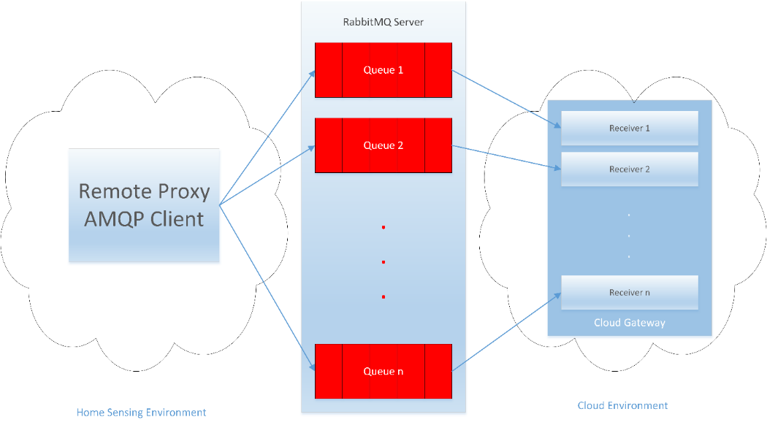

Figure 5: Message exchange between Home Sensing Environment and Cloud Environment using AMQP

### Remote Proxy

The Remote Proxy (RP) is responsible for connecting the Home Sensing Environment with the eWALL Cloud. It provides necessary interfaces for remote access and configuration of sensor and actuators in sensing environment, and is responsible for transmission of sensor data to the eWALL Cloud. It is responsible for sending processed and indexed measured sensor data, to receive control and configuration data to Sensing Environments and for bidirectional application data. It directly communicates with Cloud Gateway component from Cloud Middleware and supports both *message based* and *pull and push* communication. Currently, RP is implemented as standalone Java component that can run on any JVM

Main features of Remote Proxy currently implemented are:

* Performs registration and configuration of Remote Proxy components and Sensing Environment at eWALL Cloud via REST interface.
* Sending point of contact information from Sensing Environment via REST interface that is used for reaching Sensing Environment from remote.
* Responsible for realization of communication protocol and adaptation, especial in regards to the quality, security, capacity and reliability of the communication between the home and cloud environments. Sending all measurements data coming from WP3 device components, including accelerometer data, temperature, humidity, luminance, movement, bed sensor etc. via REST interface and AMQP messages.
* Besides implemented RESTful interface for message exchange between the Sensing Environment and eWALL Cloud, a second communication mechanism, based on Advanced Message Queuing Protocol (AMQP) has been developed for high volume/critical sensor data upload. Registration and sending of measurements from WP3 devices is currently implemented. The measurements are sent to a RabbitMQ server in different queues (one for each measurement type) and with different routing keys. The routing keys will enable future differentiation between messages coming from different eWALL systems, sensing environments or devices.
* Responsible for adaptation of data being transferred between Sensing Environment and eWALL Cloud.
* Interfaces Device Gateway to request raw/unprocessed data directly from sensor and control actuators.
* Provides security features such as token based authentication and authorization, and encryption of sent data
* Support for basic remote host system monitoring

## Service Architecture

The eWALL platform is offered to end users via applications, which are built by composition of a set of dedicated services, each one targeting specific tasks. The set of services, and consequently the set of possible applications, can be updated dynamically at runtime via-state-of-the-art Continuous Integration and Delivery strategies and tools. Services can provide either “horizontal” tasks, common to many applications (e.g. authentication, profiling, data retrieval, notifications) or “vertical” tasks specific to one or a few applications (e.g. user location, activity detection, sleep analysis). Independent of their type, all services share the same set of architectural concepts defined by the Micro Service Architecture methodology, as summarized in a list of twelve characteristics in “The Twelve-Factor App” website[1]. This architectural approach is particularly suitable for applications and services deployed in cloud-based or containerized environments and is largely adopted by top service provider companies (e.g. Amazon, Netflix, eBay) [6] as it allows for high flexibility, auto-scaling, continuous delivery and hot update of functionalities.

The need for micro service architectures and for a methodology which drives their design is due to the fact that nowadays “*software is commonly delivered as a service: called web apps, or software-as-a-service. The twelve-factor app is a methodology for building software-as-a-service apps that:*

1. *Use declarative formats for setup automation, to minimize time and cost for new developers joining the project;*
2. *Have a clean contract with the underlying operating system, offering maximum portability between execution environments;*
3. *Are suitable for deployment on modern cloud platforms, obviating the need for servers and systems administration;*
4. *Minimize divergence between development and production, enabling continuous deployment for maximum agility;*
5. *And can scale up without significant changes to tooling, architecture, or development practices.*
6. *The twelve-factor methodology can be applied to apps written in any programming language, and which use any combination of backing services (database, queue, memory cache, etc).”* [6]

As eWALL was built with microservices in mind, every building block of the system is a self-contained microservice called “Service Brick”. Accordingly, the eWALL platform is obtained by composition of a set of loosely coupled, stateless Service Bricks, talking each other via REST/HTTP protocol and exchanging data in JSON format. This kind of architecture, which is very modular and allows for a high degree of flexibility in the service provisioning, requires special handling for what concerns authentication and authorization. In traditional three-tiers, web-based systems, services are provisioned by one (or a cluster of) front-end server and the server manages subsequent requests coming from the same client by creating, after authentication (e.g. via credentials), a “session” object. Such object allows the server to maintain a status between calls, and to share with the client a temporary identifier (session id) whose lifetime lasts until explicit logout or time expiration. In the case of eWALL, the platform services are stateless and exposed by a set of different servers independent from each other (no temporary information such as session ids or status data are stored between following invocations). In this scenario, the selected approach for identifying whether a client can access a service is the so called “token-based” authentication and authorization mechanism: after a user/app logs in to a login service (providing credentials), the login server generates and returns to the client a token (encoded string), which must be transmitted by the client in every subsequent request to each service provider. The token is signed and “self-contained”, meaning that it contains information stating which services the user is entitled to use and how long. The login server, based on the credentials provided by the user and by retrieving his profile, detects which services the client can access and builds the token accordingly.

Every service, as mentioned, can be “hot deployed” in the runtime environment to add new functionalities to the platform or to update existing ones. This allows for continuous updates without system downtimes. From the technical standpoint, every eWALL Service Brick consist of a Java web application developed leveraging the Spring Boot technology [8], providing REST endpoints exposed on a defined port and packaged into a runnable archive (Jar or WAR). Depending on the underlying runtime architecture, which can consist of a cloud-based set of virtual machines each one running a Java servlet container, or a Docker-based containerized infrastructure, the proper runnable archive is automatically deployed on the runtime engine and made available to the rest of the eWALL components.

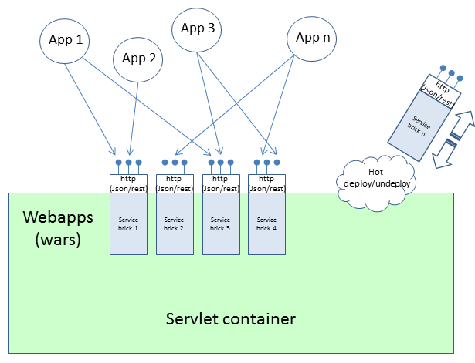

Figure 6: Hot deployment of service bricks on the runtime environment

From the functional point of view, Service Bricks act either as providers of horizontal functionalities such as authentication or profiles, or as providers of specific context-related data, built by analyzing and aggregating the raw information stored in the cloud Data Management Block, provisioned by the local sensing environments installed in the users’ homes. The eWALL applications and the reasoning modules can retrieve such aggregated data from the service bricks (via JSON/REST API calls over HTTP communication protocol). The low level metadata which feed the service bricks, is collected and sent to the Data Management Block by the home sensing environment, which gathers raw signal processing information and translates them into higher level metadata according to the eWALL architecture).

## Applications

Most the applications available in eWALL at this stage are targeting needs of COPD and MCI patients.

### Falls Prevention Program

Falls pose a physical and psychological risk for elderly people. Falls can be prevented if the elderly user of eWALL is adequately informed of the factors involved in the risk of falling and follows advice on mitigating those risks.

The Falls Prevention Program of eWALL focuses on 8 risk factors and evaluates their constituents, either utilising the user’s profile, questionnaires, or measurements from the home environment, originating from the user’s home or body.

These factors are home hazards, medication intake, vital signals, vision, feet and leg conditions, cognitive state and social life. The UI of the application is demonstrated in Figure 7.

1. 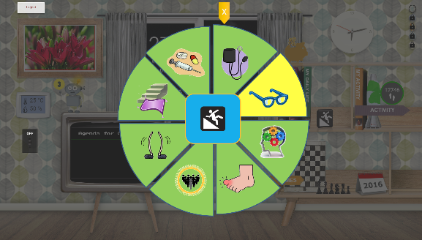 (b) 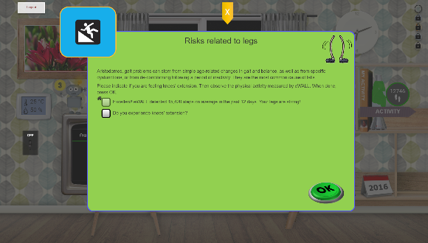

**Figure 7: Falls Prevention Program UI: (a) The eight risk factors and (b) the two constituents of the legs condition, one measured automatically by the home environment (related to the number of steps) and another asking the opinion of the user.**

### Rewards System

In order to increase overall engagement with the eWALL platform as well as tie the various eWALL applications together, an engaging reward system is implemented. Every activity of the user is rewarded by the system with virtual currency (i.e. eWALL Coins). The eWALL Coin represents a virtual credit unit for performing any kind of “good behaviour” (like taking steps, performing a video exercise, or even opening one of the health overview books. The coin cans then be used like a currency throughout the system to purchase rewards (i.e. user interface customisations).

The user interface (see Figure 8) of the rewards system shows the amount of eWALL Coins earned, specified per “source of income”. These sources are related to user physical activity and sleep quality, as well as to the user’s interaction with any of the apps, usage of the video trainer and scores in the games.

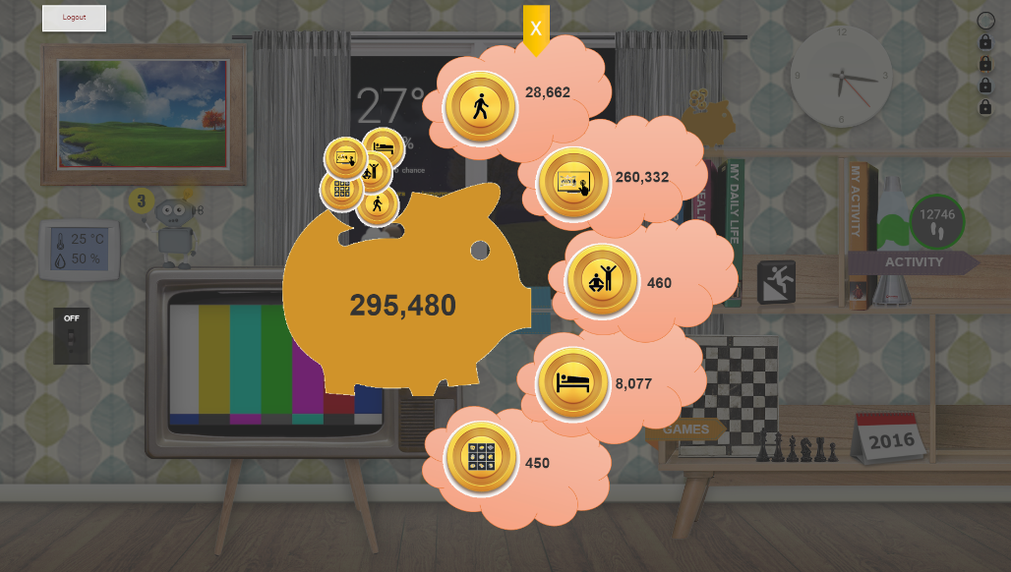

**Figure 8: Rewards System UI showing the total coins currently owned and their source.**

### Caregiver Application

The Caregiver application is a web application dedicated to caregivers, for monitoring the status of the people they are taking care of and evaluating whether actions need to be taken to better assist them. This application can be used transparently from a fixed or mobile device, therefore the GUI has been designed to be easily adaptable to mobile devices screens. The application home page shows the list of end users the caregiver is in charge to take care of. After selecting one of them, they can access to user profile data, real time data on current activity and location, home environment, physical activity, sleep quality, daily activities, cognitive game performance and health parameters. For all these categories, the caregivers can have a deeper insight on the historical data to evaluate behavioural trends. Moreover, caregivers can create personalized contents for cognitive games (Memory Quiz and Jigsaw games) which allow to tailor the games to the specific type and level of cognitive impairments that affect a selected primary user. In addition to user specific information, the caregivers can access the “Notifications” area, where a list of notifications are listed and categorized by priority, triggering date and type. The caregivers have full control on the policy for triggering the notifications, by accessing a dedicated configuration area for defining thresholds for every item to be controlled.

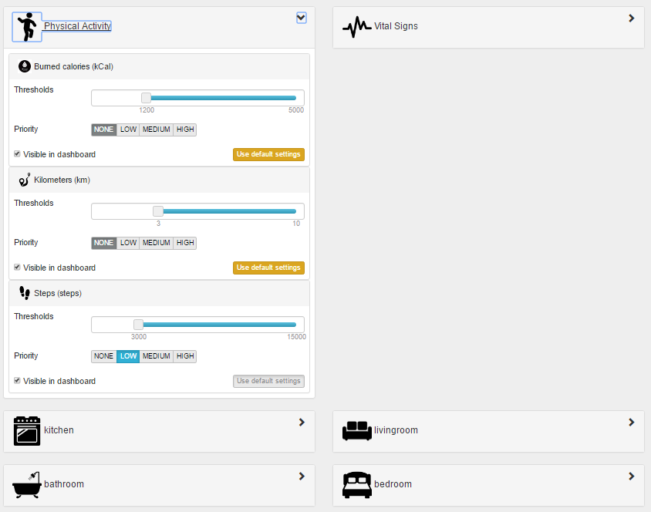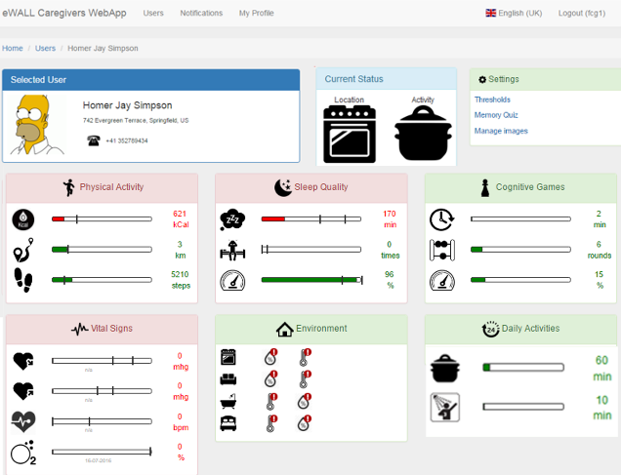

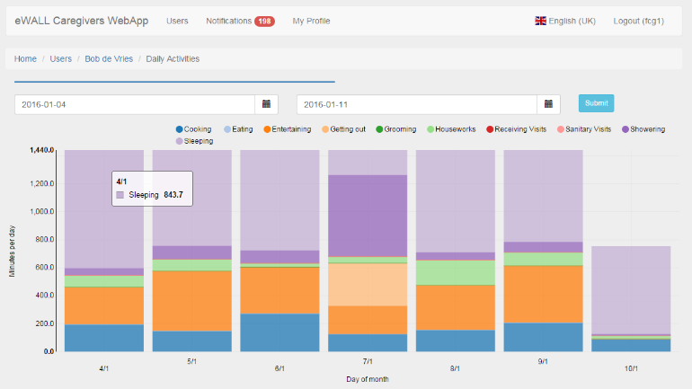

Figure 9: Screenshots from Caregiver Application: User Dashboard, Threshold notifications Settings and Daily Activities

### Cognitive Games

The development of new intervention strategies, such as the use of cognitive training platforms (based on video games), rather than directly treat cognitive decline should be considered a valid aid to preserve cognitive functions in healthy subjects and especially in those subjects with mild cognitive impairment. A great potential of these tools comes from the application in elderly subjects, to help maintaining a good quality of life and independence. Several studies have shown that the use of these platforms can improve cognitive performance in elderly healthy subjects and that the gain persists up to five years after training (Willis et al., 2006; Smith et al., 2009; Martin et al., 2011).

In the eWALL platform, all the games provide on the primary user side a feedback in terms of points, ranking and time spent for finding a solution. On the caregivers side eWALL platform provides a tracking of the game usage and interaction, in order to analyse in a qualitative way how the primary users cope with them and, as a support tool, to assess their cognitive capabilities and their trend.

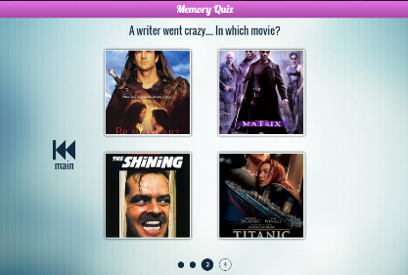**Memory Quiz Game -** eWALL users are people with memory degradation issues, therefore a visual quiz game can help them to strengthen their memory and even to recover memories of family, friends, places, etc. The Memory Quiz Game is a visual memory quiz with multiple-choice questions (based on the user’s photo gallery) regarding the user's previous experiences, acquaintances, etc. Furthermore, the game can be customized by a caregiver by uploading custom pictures and photos and associating questions to them.

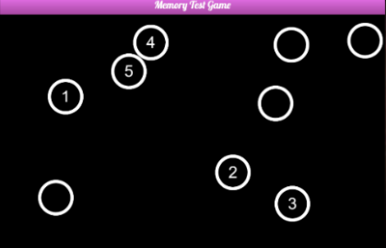**Memory Test -** The Memory Test Game helps the eWALL users to improve their memory by trying to memorize the positions of a list of numbers. In the initial gameplay screen the player sees all the numbers from 1 to 9. The goal of the game is to memorize the position of all numbers and open them in sequential order starting from 1. Three levels of difficulty are available for the user to choose from, they defer in the amount of the numbers that the user is supposed to remember. Every time the game is renewed the numbers have different position.

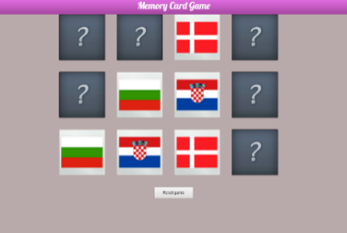**Memory Card -** The Memory Card Game is a traditional cognitive training game, in which a set of cards is laid face down on a surface and two cards are flipped face up over each turn. The object of the game is to turn over pairs of matching cards. In eWALL this game was implemented using the flags of some European countries as pictures to be matched: the user is then expected to memorize the flags and their position. The eWALL user can choose between three levels of difficulty which varies in terms of the number of cards. As feedback for assessment of the user cognitive performance, the game provides possibility to collect and show results in terms of time needed to complete a single game and number of clicks.

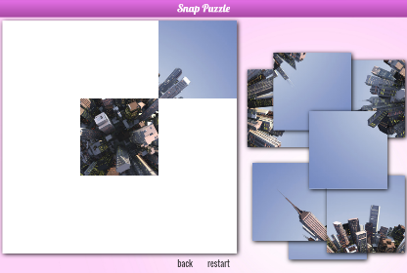**Jigsaw -** Jigsaw game has been identified by the eWALL medical partners, experts in the MCI field, as valuable means to maintain memory and attention. This game, in addition to training the logical and memory skills, allows also to involve the primary user with physical touch-based interaction with the screen. This game challenges the user to compose a unified picture by dragging and dropping small picture “tails”, each one containing a small part of a picture on it.

The user involvement is maximized by providing the possibility, in the same way as for the Memory Quiz Game, of customizing the contents. Therefore, the eWALL Jigsaw game allows the users to play with custom pictures uploaded by the caregiver, which can be more attractive for them.

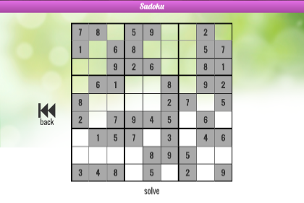**Sudoku -** Sudoku is considered to be one of the most effective games related to logical deduction and problem solving. Being it a well-known, widespread game, appreciated by people spanning from very young to elderly people, it was selected for inclusion. The Sudoku game developed for eWALL provides the possibility of changing the difficulty level to stimulate the primary user to train on it iteratively. The choice of the level impacts the number of cells to be filled in order to complete the game. The user interface was developed to guarantee an intuitive full-touch experience.

## Challenges and Solutions for the eWALL User interface

During the development of the project many challenges concerning the eWALL User Interface have been addressed, such as:

* Information architecture – how to structure and organize the gathered information in the form of services and applications
* Interaction design – how to design different interactive components, environments, systems and services
* Human-computer interaction – how to design, evaluate and implement interactive technologies for interaction between people (users) and computers
* Ergonomics – how to optimize the interaction between people and objects and designed environments
* Usability – how easily people can use a particular tool (object)
* Accessibility - how easily people can use and understand things.

During the realization of the interface the vision was that it should be as simple for users to setup the AAL services and applications and these will be supported by multiple execution platforms and can be deployed to various devices and users. To solve this challenge and to optimize the computational resources usage and overcome some shortcomings, related to slow performance issues in the retrieval of data to be presented by the applications, specialized service bricks were introduced dedicated to the preparation of data for the applications, performing proper aggregations or transformation of information in advance and in batch mode. This data is then stored in a database specific to the service bricks, and made available as “pre-digested” information to higher level service bricks thus allowing an optimization of the computational resources.

Another challenge was related to the requirement of low bandwidth consumption on the low level end of the interface and the raw data transmission from the sensors. Reasoning on raw sensory data imposes specific challenges with the data transmission. A close connection between sensors and context extraction modules is mandatory in cases when the data rates are high and there are constraints for latency in transmission. Transmitting the extracted context on the other hand, can significantly reduce data rates and alleviate a number of additional constraints. The most appropriate example is the facial analysis done on A/V data. High data rates delivered by high quality video camera (example the Kinect sensor) and on time delivery of each frame introduces challenges if this data is to be transmitted over Internet to be processed in the Cloud. A better approach is to locate the reasoning modules close to the camera sensor, extract the relevant facial data and transmit only the metadata. This is the approach followed in eWALL.

To address the requirements for the usability and accessibility a Single Page web application (SPA) technique was decided to be used, that could give any web application as seamless an experience as a desktop application. This way the majority of the interactions are handled on the client machine without the need to reach a server with the goal to provide more fluid experience and richer interaction between user interface components. In a SPA, either all necessary code – HTML, JavaScript, and CSS – is retrieved with a single page load or the appropriate resources are dynamically loaded and added to the page as necessary, usually in response to user actions. The page does not reload at any point in the process, nor does control transfer to another page. Interaction with the single page application involves dynamic communication with the web server behind the scenes. AngularJS is an open-source web application framework [9]. It assists with creating single-page applications that only require HTML, CSS, and JavaScript on the client side. The platform’s goal is to augment web applications with model–view–controller capability, in an effort to make both development and testing of the interface easier. By using this platform in eWALL we develop a fluid and effective easy to use interface (see Figure 10).

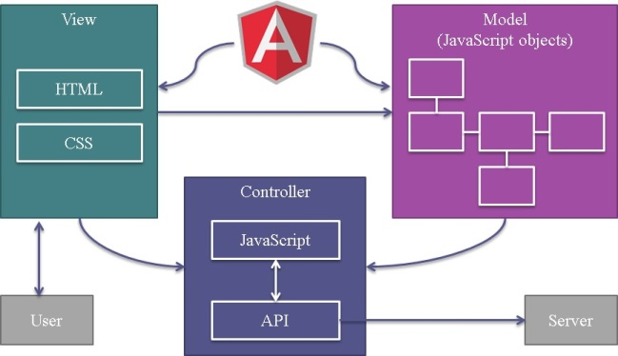

**Figure 10: eWALL Web application connection**

Finally a trivial problem with time zones during the realization of the system’s interface was encountered. Our applications need to have robust time zone support because the servers and users are located in different time zones. JavaScript does not have native support for time zones. When a date is created in JavaScript, the date object is automatically converted into the browser's local time zone (which may be different than the server’s time zone). So if any problems occur with the user for example he or she accidently falls in a problem with the difference between the time zones of the client and server, which could lead to the consequence an alarm to be late to be deployed. A solution illustrated on Fig. 3.2. was implemented using the ISO 8601 standard covering the exchange of date and time-related data between user interface and the Cloud. A functionality in JavaScript was developed employing the Olson time zone to convert this time zone format as a number and construct ISO 8601 formatting. As not all versions of the different browsers supports these data format, special provisions to cover this problem was taken.

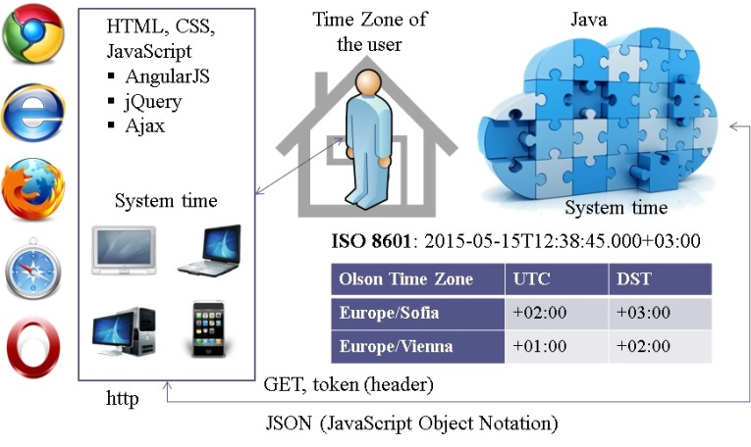

**Figure 11: eWALL time zone and date solution**

## Data protection by design

The eWALL concept and architecture was also considered from the perspective of EU privacy and data protection law. In particular, its impact on the eWALL system design and development was analysed in order to prepare for the legal obligation of “data protection by design” (DPbD) defined in Article 25 of the EU General Data Protection Regulation which will apply from 25 May 2018 (GDPR) [10]. The eWALL project includes dedicated tasks to develop an approach for DPbD. By means of multistakeholder collaboration between technical, medical and legal partners, the consortium was able to develop a credible approach to address technical measures of pseudonymisation, legal data protection principles and rights and freedoms of patients and seniors. The results can be utilised for compliance with DPbD and within the data protection management system, by those who use or purchase an eWALL system. Concerning strategic marketing goals, the eWALL project also contributed to technical standardisation and proposed the development of a European privacy standard.

Despite new sanctions, tasks and powers of supervisory authorities and other intimidating legislative innovations, the Regulation also introduces new incentives and business opportunities for ICT industry. These include several topics: data protection management systems, auditing by private entities; certification and codes of conducts (for DPbD, pseudonymisation, etc.); legal obligations of data protection by design and by default (also for international data transfers and binding corporate rules); incentives for pseudonymisation (clear definitions of personal data and pseudonymisation); and privileges for pseudonymisation (as regards data breach notifications, archiving, research and statistics as well as in relation to lawfulness, codes of conducts and data security). Although the supply side of ICT systems are not directly subject to the legal obligation of DPbD, their customers and business partners can pass on obligations to manufacturers and providers in contracts or tenders in public procurement.

eWALL project developed an approach that addresses all criteria of the legal DPbD obligation. The obligation, which is defined in Article 25 of the Regulation, refers to implementation of technical measures during the “determination of the means” for data processing. The eWALL project addressed this criterion by managing the R&D phase of an ICT system and developing legally justified technical concepts.

Besides, the only example of a technical measure for compliance that Article 25 mentions, is pseudonymisation. After having identified opportunities offered by eWALL applications, services and cloud/home sensing components, we developed a concept for a compliance solution by delivering the specification of an advanced technological method for pseudonymisation in the second year of the project. For this, we started to implement technical concepts using the example of the eWALL Activity Lifestyle Reasoner component, which processes sensor data to recognise the physical activity of a patient or senior througout the day and week. This way, we could demonstrate that the activity patterns of patients and senior can be processed using algorithmic methods to remove sensitive and identifying information elements, while ensuring the functioning of the monitoring of the activity patterns. This pseudonymisation method developed in eWALL is in line with approaches of EU privacy innovation projects in which Stelar leads the legal work package [11].

Another criterion of the DPbD duty is to meet the requirements of the Regulation. In the meaning of Article 25 pseudonymisation is only relevant as far as it promotes the legal requirements. Only to that extent will regulators favour a certain technology design over competing solutions. In eWALL, we ensured this by having delivered an approach for DPbD in the middle of the project, which assesses the legal data protection principles of European and national laws (regarding anonymisation and pseudonymisation) and the opinions of the data protection regulators in the European Data Protection Board (formerly, ARTICLE 29 Working Party on Data Protection).

Moreover, the obligation of DPbD requires organisations to take into account the “rights and freedoms” of individuals. This is necessary where the Regulation is not specific enough to guide ICT industry. In eWALL, we adressed this criterion with our deliverable on guidelines on ethics, privacy and security aspects in the beginning of the project. In particular, we examined the EU Charter of Fundamental Rights for rights of patients and seniors, business freedoms of ICT industry, and public health protection duties and goals of the EU and Members States.

Furthermore, the DPbD obligations include the criteria of considering the state of the art in technology and the legal impact on fundamental rights of individuals. In the eWALL project, the multidisciplinary consortium fulfilled the first criterion by having studied the state of the art in ICT-based home caring systems related to applications, sensors, networks, cloud computing, user interfaces, system integration, and health care services. Concerning the second criterion, the consortium’s ethical and legal experts explored the opportunities and risks for fundamental rights of patients and seniors in the context of home caring environments. The multidisciplinary collaboration was guided by a certain feedback procedure that aims to bridge the gap between lawyers and engineers in their respective disciplines [12].

Compliance with the legal DPbD obligation also needs to be monitored and demonstrated (upon request of regulators) according to Article 24 and Article 5(2) of the Regulation. These duties are referred to as accountability including data protection management systems. In eWALL, deliverables document the project’s approach to meeting the various criteria of DPbD (pseudonymisation, legal principles, rights and freedoms, bridging legal and technical collaboration) and the related project management. The eWALL deliverables enable governments, public procurers and organisations responsible for the operation of an eWALL system to monitor and demonstrate compliance with the DPbD requirement.

As a strategic business enabler, the eWALL project does not only apply the law but also develops recommendations for European policy-makers and standardisers to specify the basic legal requirement of DPbD and the related societal responsibility of ICT stakeholders who develop innovative eHealth systems. Whereas standardised best practices in the field of DPbD aim to advance innovation and competition, it can also improve quality of life and strenthen privacy and data protection for patients and seniors. The Regulation empowers the European Commission to enact decisions to request the 3 European Standardisation Organisations (ESOs) following the examination procedure to develop European Standards (ENs) for the assessment and certification of data protection conformity.

The eWALL project signed a liaison agreement with the European Committee for Standardization to contribute to its Technical Committee CEN TC 251 Health informatics [13]. Input are fed into the standards body through a dedicated eWALL Project Representative to CEN [14], who deepened collaboration by having arranged for his nomination as convenor of CEN TC 251 WG I to be voted upon by the European national standards bodies. Previously, the eWALL project also proposed standardisation work to the European Telecommunication Standards Institute (ETSI) eHealth Workshop 2014 [15]. In the project’s European standardisation activity, the eWALL Representative uses experience he gained as Representative of ANEC ‘The European consumer voice in standardisation’ who were consulted by the European Commission on drafting the standardisation request M/530, and his experience as ANEC Head of Delegation in the standards body that was created in response to the Commission request, that is, the Joint Working Group CEN-CENELEC JWG 8 Privacy management in products and services, to develop one or more ENs concerning privacy by design by early 2019 [16].

To sum up, the eWALL concept includes preliminary features that take the opportunities for the marketing of innovative eHealth systems derived from the EU legal framework. While focusing on legally-justified technical concepts, the eWALL project developed legal guidance specific to the R&D phase of ICT product development, which adds to existing technical measures (information security) and management systems for the operation of ICT systems. The eWALL concept’s features can be used as best practice to prepare for the new legal obligation of Data Protection by Design. They can be used in eHeallth projects for the development of innovative ICT products and services. Since they can also be used to support their development through European privacy standards, it is important to build alliances that support eHealth innovation in the standards committees. Interested stakeholders from the 33 member countries of European standardisation (EU28, EFTA, Turkey, FYROM), are invited to get in touch with their national body to join the standardisation activity concerning privacy management in the design and development of innovative eHealth products and services.

# Developing services and applications in eWALL

## eWALL open-source

The global ICT industry nowadays cannot be imagined without the Open Source Software (OSS). When discussing open source two meanings are possible: 1) software that is free of cost and 2) software that one can do whatever one wants (e.g. read the source). During the development of the eWALL system a special attention was put on the software, both used and developed. The choice was made from the start to make the final outcome open source and for this reason every input building block had to satisfy the software license and quality requirements. The benefits of open source such as transparency, usage of open standards, avoidance of vendor lock-in, possibly larger developer base and community were all considered when deciding for going open source.

eWALL software is released under Apache License 2.0, a permissive software license with minimal requirements that allows software to be freely used for any purpose without concerns for royalties. eWALL aims to reduce the digital divide and at the same time achieve greater market penetration. Since it is envisaged that the eWALL system should involve in the future, include some additional functionalities but also to tweak existing ones according to the specific user needs we believe going with open source will also attract new developers, researchers, institutions and possibly also companies. Apart from updating and adding new functionalities a possible improvement in code base and additional testing and continuous quick bug fixing was also on the top of the list when deciding on the future of our system.

## Development of Service bricks

The eWALL applications offer the interface of the system to the users. As such, their significance goes beyond that of a GUI; they are the endpoints where the intelligence and the personalization of the system are exposed to the users. The eWALL service bricks provide data to all the modules of the system. They offer the low-level data coming from the end user environment, which are a product of local context understanding (what can be observed in a single room of the home of a single user at a given instant of time), to the modules that perform reasoning (either at the given instant or across time). They also offer the data from the higher-level components, which describe the full context understanding of the system (across space, time and possibly multiple end users), to the applications. The service bricks are in between the applications and the metadata stored in the cloud Data Management Block (DMB), and act as providers of specific aggregated data, after making some reasoning on the metadata. The applications receive the aggregated data from the service bricks via JSON/REST over HTTP communication protocol. From a technical standpoint, the service bricks act as providers of specific context-related data, built by analyzing and aggregating the raw information stored in the cloud DMB, provisioned by the local sensing environments installed in the users’ homes. The eWALL applications and the reasoning modules (IDSS and Lifestyle reasoners) can retrieve such aggregated data from the service bricks via JSON/REST API calls over HTTP communication protocol. This stateless approach (no data are saved during request-response cycles) combined to the HTTP protocol is an architectural choice which enables scalability of the system and flexibility in the deployment scenarios.

To overcome slow performance issues in the retrieval of data to be presented by the applications a new type of service brick, “data-management” service brick, has been introduced. This allows the architecture to better cope with the metadata coming from the sensors through the Data Management layer. Such specialized service bricks are dedicated to the preparation of data for the applications, performing proper aggregations or transformation of information in advance and in batch mode. This data is stored in a database specific to service bricks, and made available as “pre-digested” information to the higher level service bricks, named “front-end” service bricks, which serve application upon request. In addition to this, for optimizing the computational resources usage (minimizing the number of artifacts deployed on the application servers), the functionalities previously offered by separate service bricks were aggregated into a smaller number of larger service bricks, having in common the management of specific categories of metadata. We passed from a model based on many small services, each one providing a few endpoints, to a model based on a few services, each one providing many endpoints.

The low level metadata which feed the service bricks is collected and sent to the DMB by the home sensing environment, which gathers raw signal processing information and translates it into higher level metadata according to the eWALL architecture. The metadata is provided to the DMB from the home sensing environment, which collects raw signal processing information and translates it into higher level metadata.

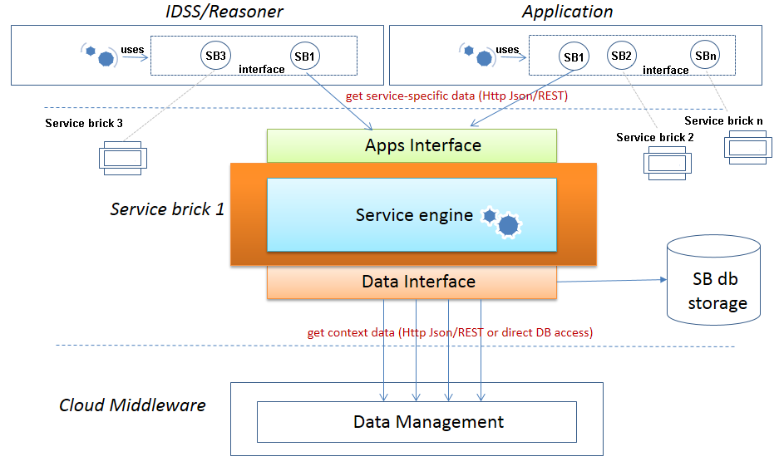

**Figure 12: Component view of a “front-end” service brick**

A service brick is composed, as shown on Figure 12 of the following software modules:

* A northbound interface, named Apps Interface, which provides HTTP endpoints to be used by applications to collect the information provided by the service brick. The endpoints are managed by a controller module, which handles the HTTP requests with the related query parameters, checks for the correctness of the parameters and forwards the requests to the Service engine (see next point), waiting for data to be sent back to the applications.
* A *Service engine* is where the business logic of the service brick is performed. The Service engine receives the requests dispatched by the Apps Interface and applies the proper actions required to satisfy them. Typical actions consist of:
  + Getting data from the Data Management layer;
  + Applying some reasoning on such data, to compose the information required by the application;
  + Returning back such information to the Apps Interface.

The Service engine consists of different computational modules delivering different kinds of data, either raw or already transformed data for specific time intervals.

* A *Data Interface,* which consists of an API for data access towards the Data Management layer. It queries the Data Access endpoints provided by the Data Management layer in the eWALL cloud and provides results back to the Service engine.

Every service brick is packaged and deployed as a *Java Web Application Archive* (war) as shown previously on Figure 6. This deployment strategy allows to leverage the benefits offered by *Java servlet containers*, which are standard, consolidated, enterprise-level runtime environments on which Java Web Applications (in our case the service bricks) can be deployed. Servlet containers provide high reliability and management features, which allow launching stop and deploy applications independently. This permits, for *hot deployment* of applications, which basically means that it is not necessary to stop the whole application server (hence, stopping the provisioning of the services running on it) just to deploy a new service brick or an updated version of an existing one. Once a service brick is deployed, the servlet container automatically activates it and the related endpoints are made available at the specified URLs for usage by the applications. If a previous version of the service brick was already present, the servlet container automatically un-deploys it and activates the new one.

As the physical activity application is one of the most important for the target users of this project, the information related to physical activity of the end user is generated and made available by two dedicated service bricks:

* “Service-brick-physical-activity-dm”: the data-management service brick, which runs in batch mode and analyses data coming from the accelerometer, calculates from them calories consumption, steps, kilometres walked, type of activity, inactivity and save this info in the service brick database;
* “Service-brick-activity”: the front-end service brick, which provides endpoint to applications and services for retrieving the data calculated by the data-management service brick, based on query parameters.

The “service-brick-physical-activity-dm”, is a component which runs on a scheduled basis. During each run, scheduled at a (configurable) rate of every 10 seconds, the service interprets the local context of a given end user, analysing the amount of movements he performed over a timeframe and combining it with user-specific data, with the purpose of estimating meaningful data related to physical activity.



Figure 13: Block diagram of Physical Activity service brick

More specifically, at every iteration it performs the following operations (see Figure 13):

* Gets the newest set of data coming from the accelerometer for each user;
* The service uses these new data to perform a set of computations and aggregations. First, it calculates the overall number of steps walked, and saves this info into the database, aggregating it by hour, day, week and month. Together with the steps, the service calculates and saves also the amount of calories consumed in every aggregation timeframe, and the related walked kilometers. Then, for each timeframe, it infers and saves the type of activity performed (one of resting, walking, running or exercising) and identifies events related to the start of activity and inactivity;
* All the above information is stored in the service brick database, for every type of aggregation;
* At the end of every iteration, temporary information describing the last known status and timestamp of latest updates is stored.

The information prepared by the “service-brick-physical-activity-dm”, is then made available to applications and services by the “service-brick-physical-activity”. This service brick manages the date and time zone verification and formatting, and the transformation of data into JSON representation. The information delivered by the “service-brick-physical-activity”, once displayed in an intuitive way on the GUI of the application, is very important to end users, as it transmits awareness about the amount of physical activity performed. The application, by comparing such data with user-specific, personalized goals (which depend on the user health profile), is able to assess the amount of activity performed and to transmit such assessment to the end user. This makes users aware that either they have done well in the last few days, or that they need to increase their physical activity.

# Acknowledgement

This document is based on the joint research work of the eWALL project consortium (EC, FP7 Grant Agreement no 610658). The authors would like to acknowledge the research effort of all eWALL colleagues for making this paper possible, as well as the European Commission for providing the FP7 funding framework.

# References

1. The eWALL project Deliverable D2.7: Final user and system requirements and architecture. March 2015.
2. TS 102 921, “Machine-to-Machine communications (M2M); mIa, dIa and mId interfaces,” ETSI, 2012.
3. Spring Framework <http://spring.io/>
4. http://www.rabbitmq.com

1. <http://projects.spring.io/spring-amqp/>

1. <http://microservices.io/patterns/microservices.html>
2. http://12factor.net/

1. <http://projects.spring.io/spring-boot/>
2. AngularJS framework <https://angularjs.org/>
3. Regulation (EU) 2016/679 of the European Parliament and of the Council
4. OPERANDO, EU call H2020-DS-2014-1, topic DS-01-2014 - Privacy, Innovation action, EU funding of ca. 4m euros, 2015–2018, “OPERANDO - Online Privacy Enforcement, Rights Assurance and Optimization” (653704), www.operando.eu
5. Pocs, Matthias, “Will the European Commission be able to standardise legal technology design without a legal method?”, Computer Law & Security Review 2012, vol. 28, pp. 641-650.
6. Liaison Agreement between eWALL Project and CEN (European Committee for Standardization), see registry of "European Partners"/"Liaison Organizations" at https://standards.cen.eu/dyn/www/f?p=CENWEB:42:::NO:::
7. Agenda/meeting notes of CEN TC 251 Health Informatics, Nederlands Normalisatie-instituut (secretariat), N16-023 and N16-048, item no. 3 (eWALL project liaison contribution), Delft, The Netherlands 2016.
8. ETSI eHealth Workshop contribution by eWALL Project, Matthias Pocs, Standardisation project proposal “Privacy-by-Design method for the development of eHealth systems”, Sophia Antipolis, France 2014, https://docbox.etsi.org/Workshop/2014/201405_EHEALTHWORKSHOP/S06_SECURITY_PRIVACY_LEGALIMPLICATIONS/STELAR_POCS.pdf
9. ANEC The European Consumer voice in standardisation, Consultation by European Commission, standardisation request on Privacy by Design for security industry, ANEC-ICT-2014-G-020final, <http://www.anec.eu/attachments/ANEC-ICT-2014-G-020final.pdf>
10. Davis, F. D. (1989). Perceived usefulness, perceived ease of use, and user acceptance of information technology. MIS Quarterly, 13(3), 319–339.
11. Laugwitz, B.; Held, T. &Schrepp, M. Construction and evaluation of a user experience questionnaire. Holzinger, A. (Ed.): USAB 2008, LNCS 5298, pp. 63-76.
12. Lawton, M.P., and Brody, E.M. “Assessment of older people: Self-maintaining and instrumental activities of daily living.” Gerontologist 9:179-186, (1969).
13. Ware JE, Sherbourne CD: The MOS 36-item Short-Form health status survey (SF-36). I. Conceptual framework and item selection. Med Care, 30:473, 1992.
14. Martin M, Clare L, Altgassen AM, Cameron MH, Zehnder F. Cognition-based interventions for healthy older people and people with mild cognitive impairment. Cochrane Database Syst Rev. 2011;(1)(1):CD006220
15. Smith GE, Housen P, Yaffe K, Ruff R, Kennison RF, et al. A cognitive training program based on principles of brain plasticity: Results from the Improvement in Memory with Plasticity-based Adaptive Cognitive Training (IMPACT) study. J Am Geriatr Soc. 2009;57(4):594–603.
16. van der Molen T, Willemse BW, Schokker S, ten Hacken NH, Postma DS, Juniper EF. Development, validity and responsiveness of the Clinical COPD Questionnaire.HealthQual Life Outcomes. 2003 Apr 28;1:13.
17. Willis SL, Tennstedt SL, Marsiske M, Ball K, Elias J, et al. Long-term effects of cognitive training on everyday functional outcomes in older adults. JAMA. 2006;296(23):2805–2814.
18. Folstein MF, Folstein SE, McHugh PR, "Mini-mental state". A practical method for grading the cognitive state of patients for the clinician in Journal of psychiatric research, vol. 12, nº 3, 1975, pp. 189–98

1.